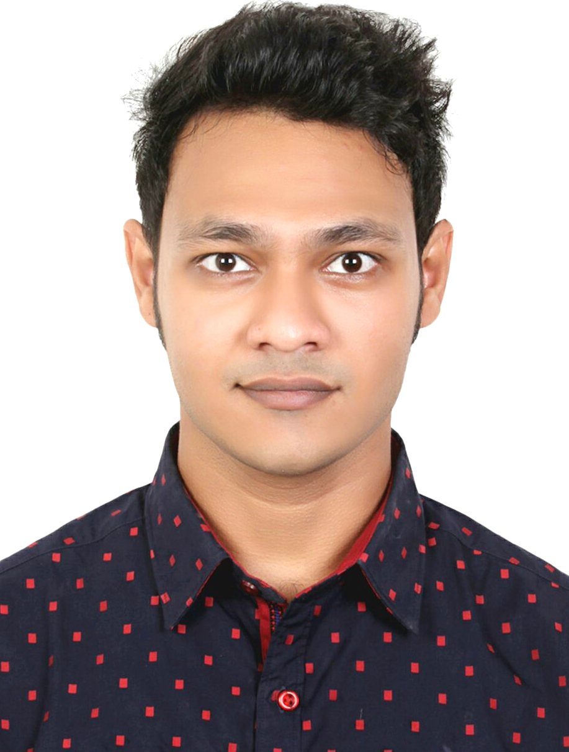
CURRICULUM VITAE
OF
Md. Saeef Hossain

House no.6/4
Block no. Professor Colony
Kalitola, Bogura
Cell phone: 01622 929686
E-mail: saeefaiub@gmail.com

CAREER OBJECTIVE

I am seeking a competitive and challenging environment where I can serve your organization and establish a career for myself.

CAPABILITIES

- Customer Relationship Management (CRM).
- Corporate Sales.
- Computer proficiency, Technology savvy.
- Presentation Skills and Negotiation.
- Self motivated and committed to work.
- Problem solving, decision making, leadership and creativity.

EXPERIENCES

Organization Name : A. H. Khan & Co.
Designation : Business Development Executive
Department : Business Commercials
Duration : From Aug 04, 2019 to till date.
Responsibilities :
- Selling & marketing of ICT products of Grameenphone Ltd.
- Corporate Sales.
- Create route plan and target customer.
- Extensive visit in corporate organization.
- Agreement signing.
- Check payment paper.
- Presenting products to the customer.
- communicating courteously with customers by telephone, email, letter and face-to-face.
- Order products and Installation.
- Provide after sales services.
- Learning about my organisation's products or services and keeping up to date with changes.

Organization Name : Grameenphone Ltd.
Designation : Trainee
Department : Business Commercials
Duration : From October 01, 2016 to March 30, 2018
Responsibilities :
- Customer Relationship Management (CRM).
- Sales (Phone, Sim, VTS, ICT).
- Handling face-to-face enquiries from customers.
- Helping to develop and implement customer service policies in an organization.
- Utility Bill Collections.
- Handle Credit and Debit Cards.
- Scan document and Business Mail.
- Communicating courteously with customers by telephone, email, letter and face-to-face.
- Keeping accurate records of discussions or correspondence with customers.
- Developing feedback or complaints procedures for customers to use.

ACADEMIC BACKGROUND

Master of Business Administration
Institute : American International University-Bangladesh
Concentration : Operations and Supply Chain Management
Year : 2020
CGPA : 3.42 (In scale of 4.0)

Bachelor of Business Administration
Institute : American International University-Bangladesh
Concentration : Tourism and Hospitality Management
Year : 2016
CGPA : 2.62 (In scale of 4.0)

Higher Secondary Certificate
Board : Rajshahi Board
Institute : Govt. Azizul Haque College
Area of study : Business Studies
Year : 2009
Result : 4.30 (In scale of 5.0)

Secondary School Certificate
Board : Rajshahi Board
Institute : Armed Police Battalion Public School & College, Bogura
Area of study : Business Studies
Year : 2007
Result : 5.00 (In scale of 5.0)

KEY SKILLS
Application software
MS Excel, MS power point, MS Word, CRM, Photoshop, Word press and Internet browsing.

Language proficiency
- Bengali : Fluency in Writing, Listening & Speaking.
- English : Fluency in Writing, Listening & Speaking.

TRAINING RROGRAM

- Participating in ‘Retail Excellence Training’ during on October 01 to October 02, 2017. Trained by Grameenphone Ltd. & Organized by BRAC CDMA.

SEMINAR PARTICIPATE

- Participates in Seminar on ‘Employee Motivation’ on March 02, 2018. Organized by American International University Bangladesh.
Chief Guest:
Mr. Solaiman Sukhun, Employee Motivator Airtel Bangladesh.

PERSONAL DETAILS

Mother’s Name : Fouzia Yasmin
Father’s Name : Md. Shahid Hossain
Place & Date of Birth : Bogra, 4th Oct 1993.
Health : Height 175cm and Weight 66kg
Marital Status : Single
Nationality : Bangladeshi (by birth)
Interest : Chase, Bikes, Coin Collection.
Permanent Address : Professor Colony, Kalitola, Bogra 5800, Bangladesh.

REFEREES

Md. Mashuqur Rahman Md. Fahim Islam
Service Supervisor Deputy General Manager
Grameenphone Ltd. Grameenphone Ltd.
Dhanmondi Center, GP House
Dhanmondi 27, Dhaka Bashudhara
Cell Phone: 01711507759 Dhaka – 1229
E-mail: mashuq@grameenphone.com H Phone: 01711506224
Cell Phone: 01711506224
E-mail: fahim@grameenphone.com

I do hereby declare that all information have presented are true to my knowledge, if required & where applicable, this document can be supported by appropriate authentic certificates / papers

_________________________
Md. Saeef Hossain

